2026 Bethel Youth Fiddle & Guitar Camp Registration
Sunday, June 14 – Friday, June 19, 2026

Open to youth age 7 – 17 interested in learning to play fiddle or guitar or sharpen already learned skills. Space and Enrollment is limited to 25 so register early. Please print or type.

I am applying for: fiddle___ guitar___ (check one or both, realizing time will be split between the two)

Please circle T-shirt size: Youth – Small, Med, Large; Adult – Small, Med, Large, X large, XX large,

Name _____________________________________________________________________________

Address ___________________________________________________________________________

City _______________________________________________ State_________ Zip______________

Phone _______________________ Email ________________________________________________

How long have you been playing your instrument? _________________________________________

List up to four of your favorite old-time tunes that you can play:

Have you learned tunes from records, tapes, or CDs? Yes_________ No __________

Can you read music? Yes_________ No __________

List any instruments you play in addition to fiddle:

_________________________________ ________________
Signature Date

Return completed application and $350 check payable to Bethel German Colony by May 10, 2026.
Remember, camp will be limited to 25 and will be filled on a first come basis.

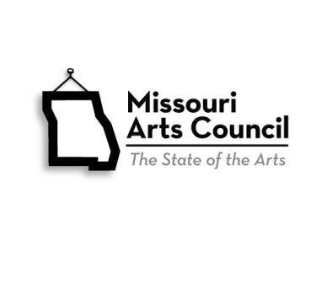
John P. Williams
c/o Youth Fiddle Camp
12129 Route K
Madison, MO 65263

For more information, call John P. Williams at 660-676-8918, or e-mail bethelfiddlecamp@gmail.com

Held at Historic Bethel German Colony, Inc. • 127 North Main St., Bethel, MO 63434
www.historicbethel.org

